360 Degree Rotating Fire Protection System

Large factories, warehouses, and industrial production facilities always run the risk of fires breaking out. Lack of appropriate firefighting measures could result in disastrous consequences and along with financial losses and might even lead to massive loss of human life.
Usual fire protection systems installed in buildings have the following disadvantage
- They spray small amounts of water from each sprinkler which may not be enough to put out the fire.
- The sprinklers are not targeted and spray an entire floor or building ruining computers, furniture and paperwork.
- While this sprayer gun can spray water in desired qty only at fire outbreak point to stop fire without ruining complete office furniture and electronics.
- This demo version is made to be remote controlled from few meters but future version will operate remotely from fire dept.
Fire monitors and sprayers are an aimable and controllable high-capacity water jet used to deal with large fires. Unlike Fire extinguishers, Fire Monitors are permanently installed and cannot be moved.
While traditional fire monitor systems need a human operator to change the direction of the water jet and aim it appropriately, this fire monitor has been equipped with RF control and an onboard camera. Thereby allowing the user to operate it from a safe distance.
The system makes use of 2 x Motors coupled with a powerful sprayer motor with piping system and onboard wireless streaming camera to run this system. The 2 motors are used to control the nozzle direction movement.

The user may use a wireless remote to transmit movement commands. The receiver circuitry mounted on system receives users commands and operates the motors to achieve desired motion. Also the receiver operates the pump motor to start and stop the spray.

The sprayer nozzle can also be adjusted to adjust the water spray outlet. The sprayer mechanism is built to operate in a 2 DOF operation to adjust position in x and Y directions and achieve a 360 Degree water spray coverage.
Components:
- Pump Motor
- DC motors
- Controller Remote
- Receiver Circuitry
- Pipings and Nozzle
- Pipe Joints and Fittings
- Bearings
- Rotating Frame
- Base Frame
- Supporting Frame
- Screws and Bolts

Applications:
- Useful for controlling indoor fires.
- Can provide a low cost fire protection system with limited centralized fire protection.

Advantages:
- Targeted water spraying to avoid water damage in office
- Remote controlled operation ensures operator remains safe
- Adjustable Nozzle for Spray Tuning
- Powerful Long Distance Water Spray
Block Diagram:

Front View
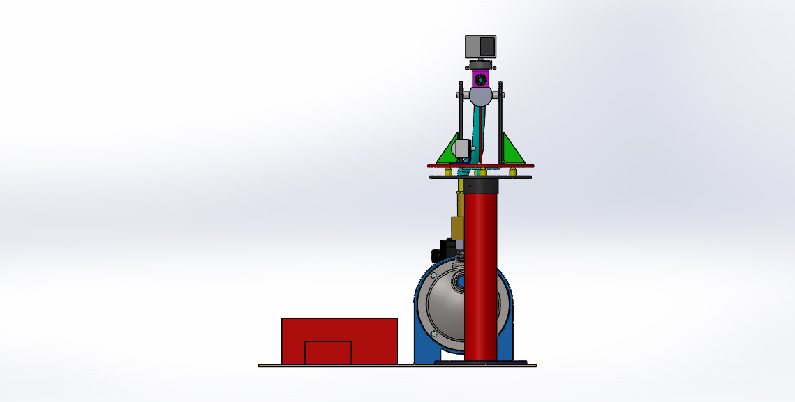

Side View
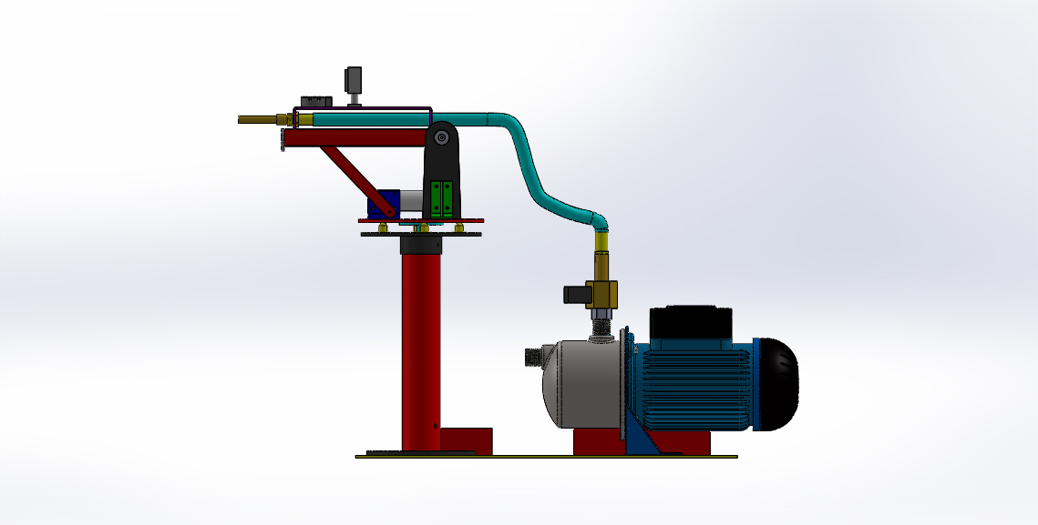

3D View
